ANGELWINGS COMPREHENSIVE COLLEGE, MAROKO, PW, KUBWA, ABUJA.
3rd TERM EXAMINATION 2025/2026 ACADEMIC SESSION.
SUBJECT: EAD
CLASS: NURSERY ONE
INSTRUCTION: ANSWER ALL QIESTIONS.
1. Draw and colour a ball

2. Draw and colour a square.

3. Name and colour the given image
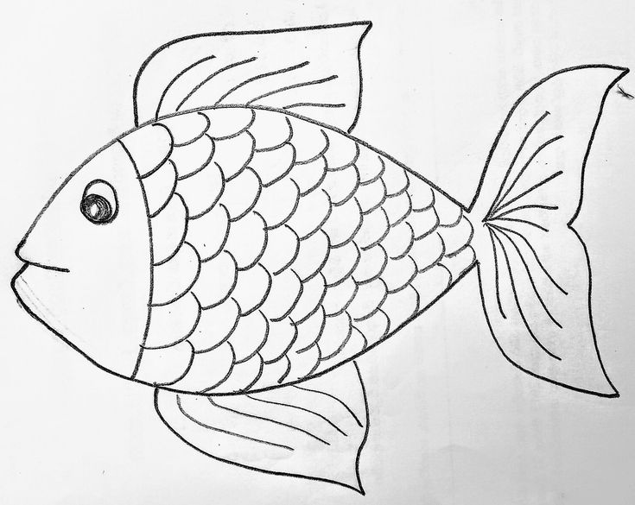

5. Mention 3 things that float in water

